

User Manual

Table of Contents
Download AndrOS 3
Flash AndrOS 4
Run AndrOS 5
Commands 6

Download AndrOS
Download the latest version of AndrOS from GitHub by going to https://github.com/steelswords/andros/releases/. Click on “Assets” to expand your options and then click on the AndrOS.iso file to download it.
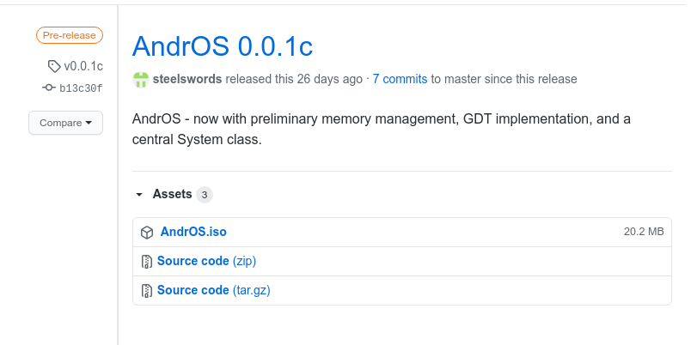

Flash AndrOS
In order to use AndrOS, it must be flashed onto a USB drive. All data on this USB drive will be deleted in the process, so be sure to back up any important data on it.
Once you have inserted a USB drive you don’t mind erasing into your computer, download Etcher (http://etcher.net/). Select the AndrOS.iso file you downloaded, select the USB flash drive you will use for AndrOS, and click the “Flash!” button.
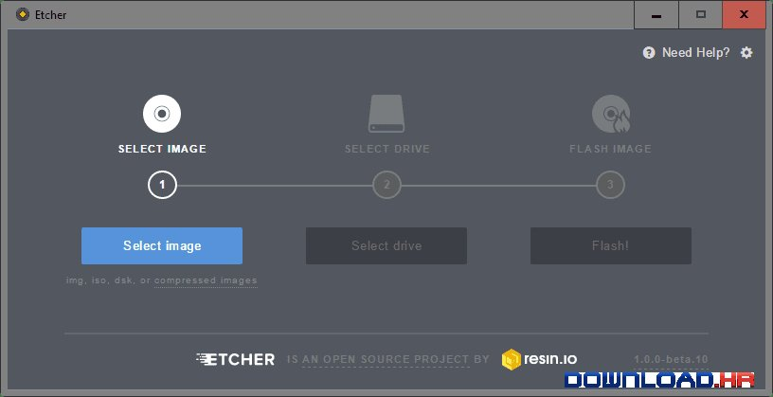

Once Etcher has completed flashing AndrOS to the USB drive, safely eject the USB drive from your computer. Remove the USB drive and reinsert it. Next, it is time to run AndrOS.

Run AndrOS
To run AndrOS, you must have completed the Download and Flash steps from above.
With the AndrOS USB drive inserted, restart your computer. While it is restarting, press the F12 key over and over until you see a menu that shows the name of your USB drive. Select this option with your arrow keys and press the Enter key. You will be greeted by AndrOS terminal prompt, as seen in the figure below. Now you can enter any of the supported commands found in the Commands section.

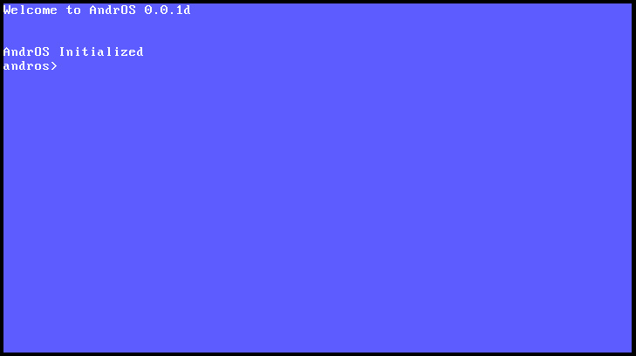

Commands
Below is a list of all the commands you can enter into your AndrOS system. If a command takes additional data, called an argument, it will be expressed using angular brackets, like so:
CommandName <argument 1> <argument 2>
To enter such a command, first type the command name, and then the value of the arguments encased in angular brackets. For instance, if I wish to peek at memory location 0x12345, I would enter peek 0x12345 into the terminal prompt.
Following is a list of AndrOS commands and their descriptions.

Greet
Command: greet
Description: Prints a friendly greeting to the screen. This command is largely used for testing keyboard connectivity.

Memory Map
Command: memmap
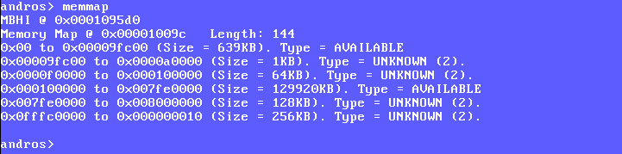
Description: Prints a map of available memory. The map shows the sizes, locations, and use types of all blocks of memory.

